Short notes on time with client: * 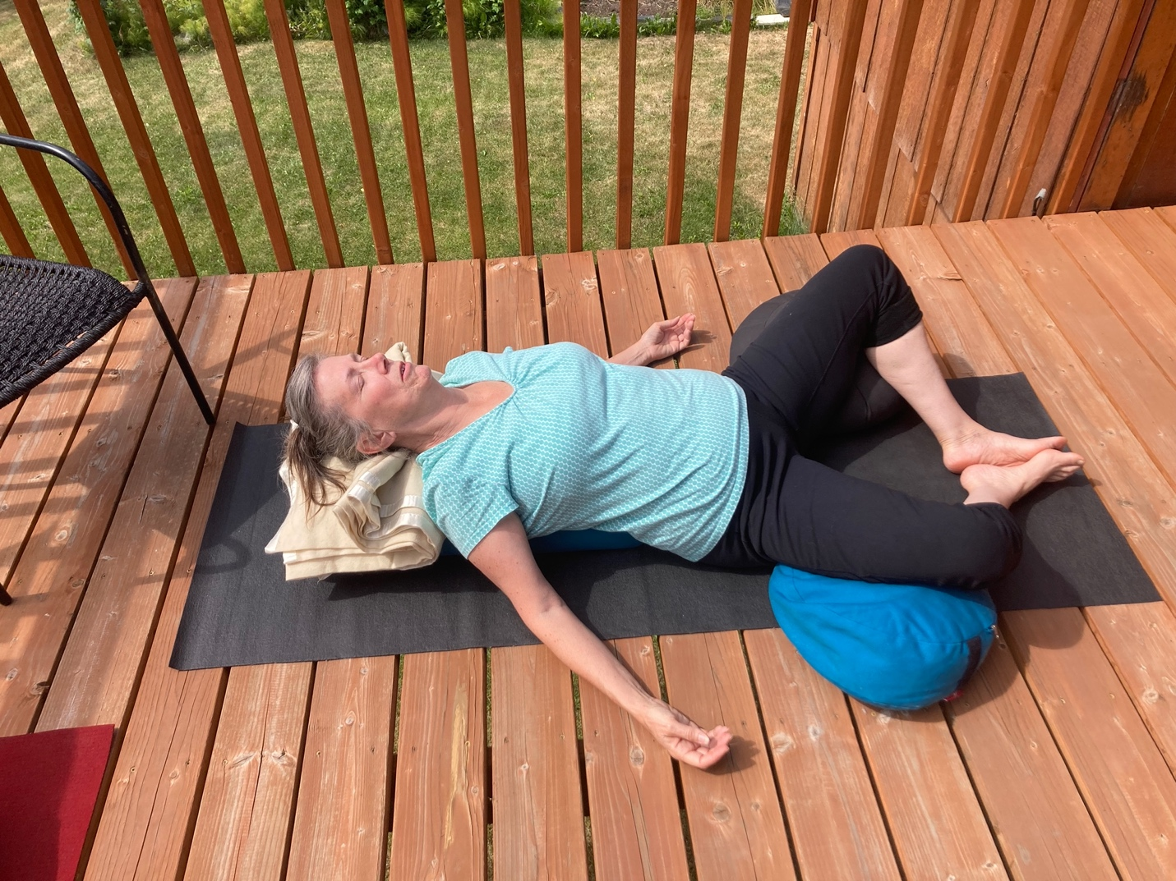
First: Resting Butterfly, Propping L and R knee for respective comfort. Once comfortable begin breathing with increasing depth and length. Next breathe into chest feel ribs expand all directions, relax abdomen and let it expand. As exhale use lower abdominal muscles to gently contract aiding long slow exhale. Continue guided breath x6 then Let go of breath control and know O2 from plants is increasing your internal energy and with your exhale yu can feel supported like deep tree roots in the ground. Feel the earth’s energy at bottom of sacrum planted solid, you’re getting nourished by the earth’s soil. As return slowly and with very little movement lift knees together and apart a few time before rolling to your good hip side. Second: Elevated Twist (adapted to a folded blanket under hip to allow a slight elevation) Again 3 elongated deep breaths once comfortable in position.
Go to your comfortable place peaceful, happy, perfect T, beach, meadow, your bed… feel the air, sense the ground under you, hear the sounds, lay back, looking at the sky, are there clouds? As your mind has thoughts attach the thought to a cloud or bird and let it go, just play with the idea…. Now we will switch sides RPT. Third Final relaxation first knees to chest -apanasana then get all settled- Body scan feet to head. 10 min each asana, twist 4-5 each side. See pictures