Client Lo typed intake

Yoga Therapy Full Intake Form
Yoga Therapist Intern: Nieda Tice + 240-222-2342 + niedalynn@gmail.com

Name: Client Lo

Yoga therapy uses the principles and tools of yoga, applied to the individual (you), with a specific physical, emotional or spiritual goal in mind.

Please consider the following questions. The answers can be written or discussed. Please ask if you have any questions about anything here.

(Focus on the questions in bold. The others are optional, and may not be relevant to your situation, or may be discussed at a later date.)

Please return to me (Nieda) at our next meeting or email to niedalynn@gmail.com

++++++++++++++++++++++++++++++++++++++++++++++++++++++++++++++++++++++

What is your yoga experience? [include experience in asana (physical postures), pranayama (breathing practices), yoga philosophy, or meditation]

200 hr YTT

Do you have a regular yoga practice?

Yes, deep, but inconsistent.

What are your goals/expectations for your yoga practice?

Consistency, understanding of philosophy, better sleep

What aspects of yoga interest you?
Asana - pranayama (breathing practices) - philosophy - meditation
ALL

When you close your eyes, are you able to visualize [see] images/faces/etc?

Describe your current level of physical activity or exercise.

Inconsistent yoga practice, found a new yoga studio in new area; walking in new neighborhood

How would you rate your level of stress? How do you respond to stress? What has worked for you to reframe / release / relieve stress?

Self reports stress as High due to “stuff going on”
Recent move
Family issues

What medical conditions have affected your health in the past? Please note which conditions currently affect you.

Ankle pain, teeth grinding (invisalign) from stress

Are you under the care of a physician or mental health counselor?
Nothing right now

May I contact them to discuss your progress or participation in yoga therapy? (additional form needed)

Are you experiencing pain today?
Please describe and/or indicate on the diagram:
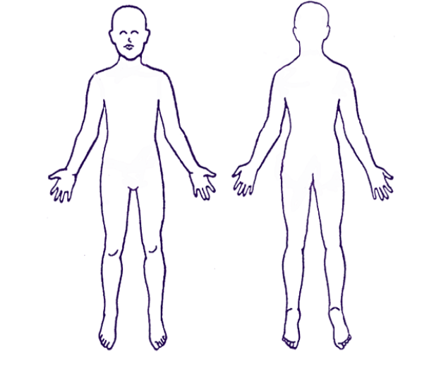 ankle pain

What medicines or supplements are you currently taking?

Do you smoke? In the past?

Do you drink alcohol? In the past? Drug use? In the past?

Are you in recovery from any addiction, behavior, or relationship?

Are you working on, or in treatment for, any mental health/psychological issues?

Do you consume caffeine? At what time of day?

Describe your diet.

Please describe your energy level.

good

Describe your sleep. Do you go to sleep easily? Stay asleep? Wake feeling rested? Nap during the day? Do you have a typical sleep schedule?

Goes to sleep easily, wakes during the night, can’t turn off brain, no trouble staying awake during the day
Reads before bed, in bed 9:30-10, wakes at 2:30-3 am

What do you do for fun? Are there things you really like to do (whether you are currently doing them or not)? Things you really dislike doing?

Yoga, walking, nature walks, forest bathing, music, going to the beach

When do you feel connection (connected to a whole, to others, to a higher power, nature, etc)?

In nature

Do you have any spiritual practices? What spiritual practices are (or have been) meaningful to you?

Feels that connection in the forest and at the beach

Are you working towards any general or specific life goals?

Adjusting to retirement (retired 2 years early to move)

Is there anything else you would like to share?

