
Name:
Address:
Primary phone number:
Email address:
Date of Birth:
Emergency contact:
Physician: Contact info:

Current diagnosis: B-cell Non-hodgkin Lymphoma
Current treatment: 6 rounds of chemotherapy (5 days each round, every 3 weeks). Completed 5th rounds and the 6th round will be on July 1st
Are you familiar with yoga? yes
If so, what is your experience? Have taken class at a gym
How would you describe your general health? ___Great ____ Good ___Okay ____ Fair____ Poor
Do you have any physical limitations? Cannot bend forward – blurry vision, lightheaded.
Do you have any injuries? No
Have you had surgeries within the last 12 months? No
Please list any prescription of non-prescription drugs you are taking and describe what they are for:

Past Medical History, (please check)
___ Asthma __Heart disease ___ High Blood Pressure ___ Low blood pressure ___Diabetes ___ Stroke ___ Cancer ___Seizures ___Thyroid Disease ___ Glaucoma/Detached Retina
___ Covid-19 ____ Arthritis ___ Fatigue ____ muscular injuries ____ Osteoporosis
____Other conditions ________________________________
Please circle or write in the provided space areas of pain, numbness, or discomfort on the drawing below:
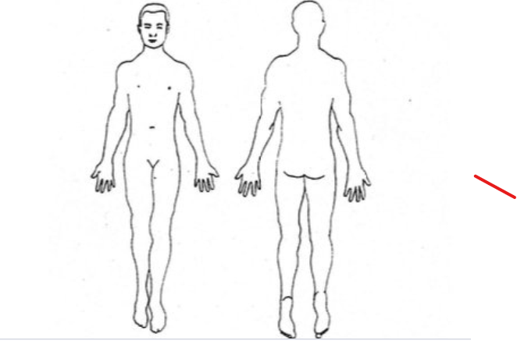

none
On a scale of 0-5 (0 = no issue, 5 = extreme), how would you rate your stress currently in the following areas
- Health-related 3
- Work/study-related 1
- Relationship 0
- Financial stress 2
- Concerns about the future 2
- Others 1
Where do you feel on your body when you are stressed? Neck and shoulders, upper back

On a scale of 1-5 (1 = poorly, 5 = very well), how well do you sleep? When in the hospital 1, at home 3
On a scale of 1-5 (1 = low, 5 = very high), what is your overall energy level? 2/3
How interested are you in Yoga practices to support the following goals (1=not interested,
2=moderately, 3= very interested)
• Physical health and wellbeing ________3__________
• Mental health and resilience ________3_____________
• Stress reduction ________________3__________________
• Improved focus __________________3________________
• Enhanced quality of life ___________3__________________
• Spiritual growth _________________2__________________
What time of the day when you have most energy (morning, during the day, evening)? Late morning
Do you have any rituals? Yes If Yes, what are your rituals breathing and exercise, meditate (guided meditation, 5 to 10 minutes, spotify) every morning, music –
How would you describe your social support system?
___x___ Exceptional _______Strong ________ Okay _______ Marginal ______ Poor
Do you have a religious/spiritual orientation? No, but love being in nature, feeling connected with nature
What brings you joy? Family, friends, comedy (laughter), animals, being active, video games
What are specific reasons for you to seek yoga therapy?: want to get back to yoga, support the health, mind and body connection.
Are there anything else that you would like me to know? Not at the moment.

