
Name:
Address
Primary phone number:
Email address:
Date of Birth: 05/08/1947
Emergency contact:
Physician: Contact info:

Current diagnosis problem: Chronic Inflammation Response Syndrome
Current treatment: Shoemaker Protocol – I am close to last steps that will correct low VIP [Vasoactive Intestinal Polypeptide] when I can pass the eye test, be in a low toxin environment, have nasal culture free of marcons and register normal serum lipase levels.
Are you familiar with yoga? yes
If so, what is your experience? I was in Lilo’s class for many years – 2004 - - - ?
How would you describe your general health? ___Great ____ Good ___Okay __X__ Fair____ Poor
Do you have any physical limitations? No – I am fussed (L4,L5 &S1) but I can touch the floor with straight legs (most days)
Do you have any injuries? No
Have you had surgeries within the last 12 months? Hernia surgery this past May
Please list any prescription of non-prescription drugs you are taking and describe what they are for:
Attaching

Past Medical History, (please check)
___ Asthma __Heart disease _X__ High Blood Pressure ___ Low blood pressure ___Diabetes ___ Stroke ___ Cancer ___Seizures __X_Thyroid Disease ___ Glaucoma/Detached Retina
___ Covid-19 ____ Arthritis _X__ Fatigue ____ muscular injuries ____ Osteoporosis
____Other conditions __My Thyroid is a condition (hypothyroidism) not a disease ________
Please circle or write in the provided space areas of pain, numbness, or discomfort on the drawing below:
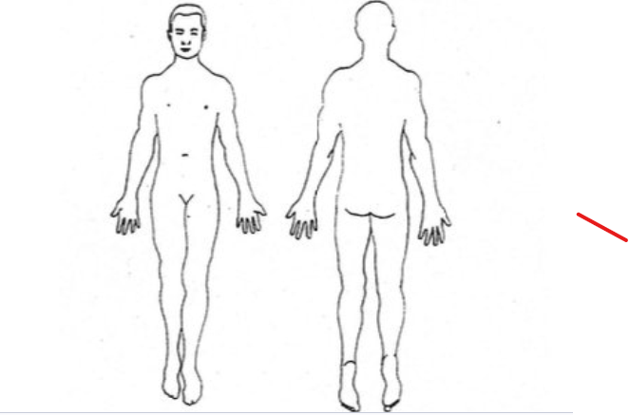

Joint stiffness, muscles not used to being stretched but not painfully so

On a scale of 0-5 (0 = no issue, 5 = extreme), how would you rate your stress currently in the following areas
- Health-related 3.5
- Work/study-related
- Relationship
- Financial stress
- Concerns about the future 3
- Others

Where do you feel on your body when you are stressed? All over Fatigue and mental brain fog

On a scale of 1-5 (1 = poorly, 5 = very well), how well do you sleep? 3
On a scale of 1-5 (1 = low, 5 = very high), what is your overall energy level? 3 days of the week 3 or 4, 4 days 1 or 2 to rest up
How interested are you in Yoga practices to support the following goals (1=not interested,
2=moderately, 3= very interested)
• Physical health and wellbeing ________3_____________
• Mental health and resilience _________3____________
• Stress reduction ________________3__________________
• Improved focus _______________3___________________
• Enhanced quality of life __________3___________________
• Spiritual growth ______________3_____________________

What time of the day when you have most energy (morning, during the day, evening)? Morning
Do you have any rituals? I like to sleep and eat with regularity…. If Yes, what are your rituals

How would you describe your social support system?
______ Exceptional ___X____Strong ________ Okay _______ Marginal ______ Poor
Do you have a religious/spiritual orientation? I have strayed from organized religion and find solace in nature
What brings you joy? My husband, children, Buddy the dog, friends, pollinator gardens, butterflies, native bees, well grown and prepared vegetables and fruits, walks in the woods, music
What are specific reasons for you to seek yoga therapy?: This cytokine storm inflammation has greatly diminished my ability to (think &) walk with balance and grace. I don’t believe I can get back to where I was physically 3 or 4 years ago without help. I have tried going to a DO for structural manipulation and also a physical therapist but it falls short of what I achieved in Lilo’s class. I need to get back there or lose everything slowly as I age.
Are there anything else that you would like me to know? Thank you for listening to me I’ve ordered a new mat I’m ready to begin better rituals.

