
Name:
Address:
Primary phone number:
Email address:
Date of Birth:
Emergency contact:
Physician: Contact info:

Current diagnosis: Spinal stenosis of the lumbar
Current treatment: Physical therapy. Did try steroid shot, but no improvement.
Are you familiar with yoga? Yes
If so, what is your experience? Had taken classes in the past, but not recently
How would you describe your general health? ___Great ___x_ Good ___Okay ____ Fair____ Poor
Do you have any physical limitations? Loss range of motion of knee and hip
Do you have any injuries? Yes. Soft tissue damage, ACL of both knees and meniscus damage. This happened decades ago.
Have you had surgeries within the last 12 months? Yes, gall bladder removal.
Please list any prescription of non-prescription drugs you are taking and describe what they are for: None

Past Medical History, (please check)
___ Asthma __Heart disease ___ High Blood Pressure ___ Low blood pressure ___Diabetes ___ Stroke ___ Cancer ___Seizures ___Thyroid Disease ___ Glaucoma/Detached Retina
___ Covid-19 ____ Arthritis ___ Fatigue __x__ muscular injuries ____ Osteoporosis
____Other conditions ________________________________
Please circle or write in the provided space areas of pain, numbness, or discomfort on the drawing below:
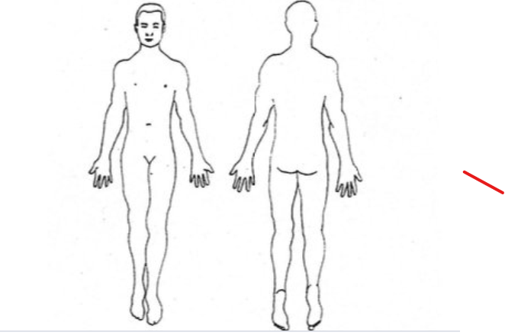

On a scale of 0-5 (0 = no issue, 5 = extreme), how would you rate your stress currently in the following areas
- Health-related 4
- Work/study-related 0
- Relationship 0
- Financial stress 0
- Concerns about the future 3
- Others

Where do you feel on your body when you are stressed? Have never noticed.
On a scale of 1-5 (1 = poorly, 5 = very well), how well do you sleep? 3
On a scale of 1-5 (1 = low, 5 = very high), what is your overall energy level? 2

How interested are you in Yoga practices to support the following goals (1=not interested,
2=moderately, 3= very interested)
• Physical health and wellbeing ______3_______________
• Mental health and resilience ________3_____________
• Stress reduction __________________2________________
• Improved focus ___________________3_______________
• Enhanced quality of life ____________3_________________
• Spiritual growth __________________3_________________

What time of the day when you have most energy (morning, during the day, evening)? During the day
Do you have any rituals? No If Yes, what are your rituals
How would you describe your social support system?
______ Exceptional ____x___Strong ________ Okay _______ Marginal ______ Poor
Do you have a religious/spiritual orientation? Yes
What brings you joy? Everyday and accomplishment.
What are specific reasons for you to seek yoga therapy?: To reduce pain in the back and improve range of motion
Are there anything else that you would like me to know?

